A000-AFR-EGY-Ushabti-Isis Priest-Light Blue Faience-600 BCE

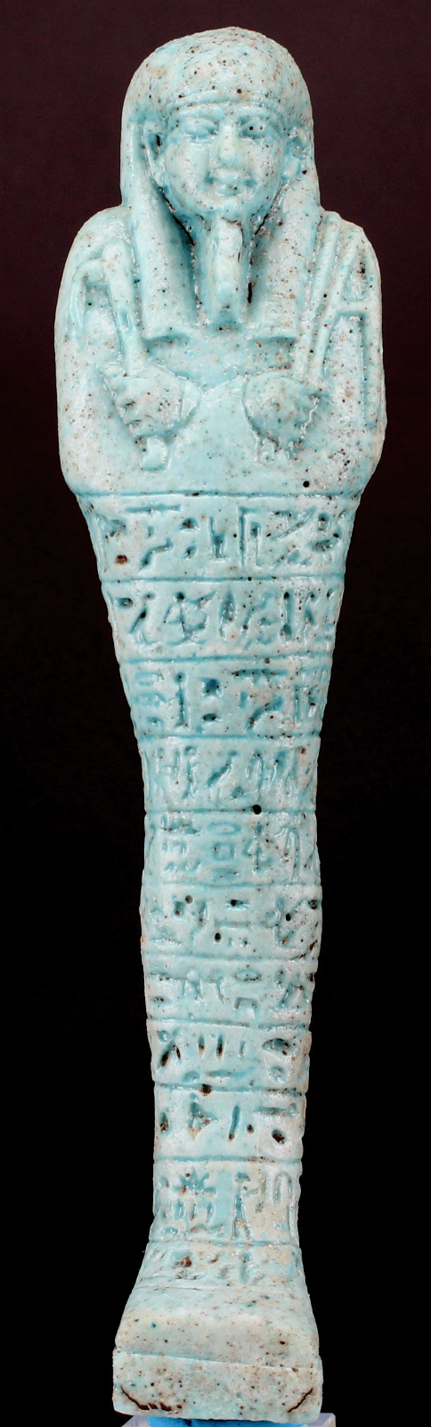 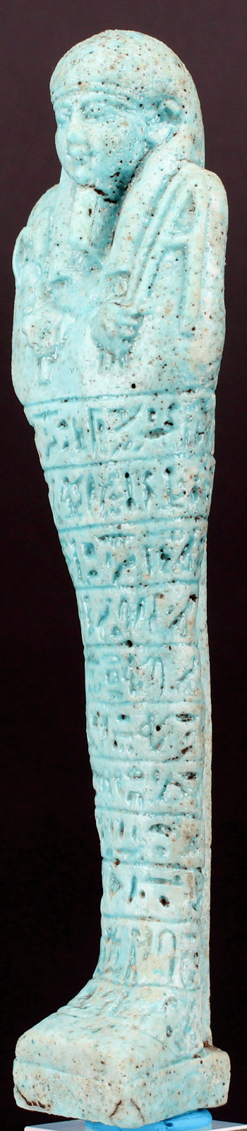 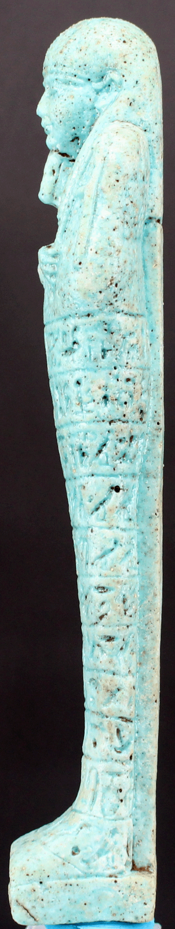 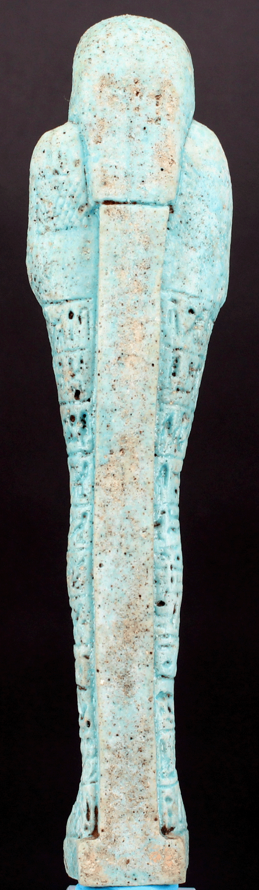

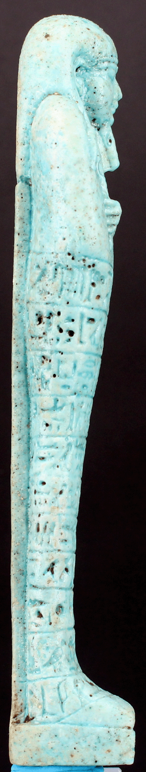 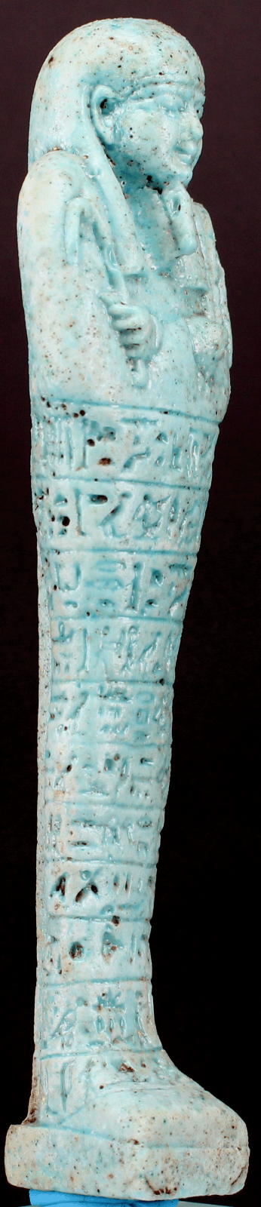 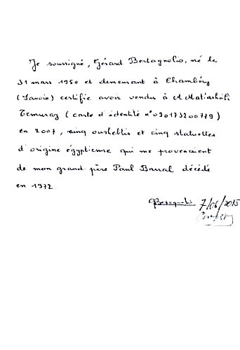

**Case no.:**

**Accession Number:**

**Formal Label:**

**Display Description:**

"Nesptah priest sameref, prophet of Isis"

Shabti wearing striated tripartite wig, raised agricultural implements and braided beard. It is inscribed on nine lines in the name of "Nesptah" priest sameref, prophet of Isis. It should be noted that this is a thinner model than those known. Blue green earthenware.

**LC Classification:**

**Date or Time Horizon:**

**Geographical Area:**

**Map:**

**GPS coordinates:**

**Cultural Affiliation:**

**Media:**

# ****Dimensions:**** H 16.5.cm.

**Weight:**

**Condition: original.**

**Provenance:**  
The seller guarantees that he has obtained this lot legitimately  
This item is from a French collection Mr. Paul Barral. Acquired in Cairo in 1967.

**Discussion:**

**References:**